Business Unit
Mobile Failures Report
ASAP 7.0.2 – JAMU66

Week 34
August 20th to August 26th, 2018

August 27th, 2018

Contents

1 Percentages for all mobile activations, changes and deactivations Anguilla 4
2 Percentages for all mobile activations, changes and deactivations Antigua 5
3 Percentages for all mobile activations, changes and deactivations Barbados 6
4 Percentages for all mobile activations, changes and deactivations British Virgin Islands 7
5 Percentages for all mobile activations, changes and deactivations Cayman 8
6 Percentages for all mobile activations, changes and deactivations Dominica 9
7 Percentages for all mobile activations, changes and deactivations Grenada 10
8 Percentages for all mobile activations, changes and deactivations Jamaica 11
9 Percentages for all mobile activations, changes and deactivations Monserrat 12
10 Percentages for all mobile activations, changes and deactivations Saint Vincent 13
11 Percentages for all mobile activations, changes and deactivations Turks and Caicos 14
12 Percentages for all mobile activations, changes and deactivations Santa Lucia 15
13 Percentages for all mobile activations, changes and deactivations Saint Kitts and Nevis 16
14 Top 5 failure issues Anguilla 17
15 Top 5 failure issues Antigua 17
16 Top 5 failure issues Barbados 17
17 Top 5 failure issues British Virgin Islands 18
18 Top 5 failure issues Cayman 18
19 Top 5 failure issues Dominica 19
20 Top 5 failure issues Grenada 19
21 Top 5 failure issues Jamaica 19
22 Top 5 failure issues Monserrat 20
23 Top 5 failure issues Saint Vincent 20
24 Top 5 failure issues Turks and Caicos 20
25 Top 5 failure issues Santa Lucia 21
26 Top 5 failure issues Saint Kitts and Nevis 21
27 Failure numbers Anguilla 22
28 Failure numbers Antigua 22
29 Failure numbers Barbados 23
30 Failure numbers British Virgin Islands 25
31 Failure numbers Cayman 25
32 Failure numbers Dominica 26
33 Failure Numbers Grenada 26
34 Failure numbers Jamaica 26
35 Failure numbers Monserrat 28
36 Failure numbers Saint Vincent 28
37 Failure numbers Turks and Caicos 28
38 Failure numbers Santa Lucia 31
39 Failure numbers Saint Kitts and Nevis 32

Percentages for all mobile activations, changes and deactivations Anguilla

 | TOTAL | COMPLETE | FAILED | % Total | % COMPLETE | % FAILED
ACTIVATE | 42 | 42 | 0 | 6% | 100% | 0%
DEACTIVATE | 73 | 73 | 0 | 10% | 100% | 0%
MODIFY | 586 | 574 | 12 | 84% | 98% | 2%

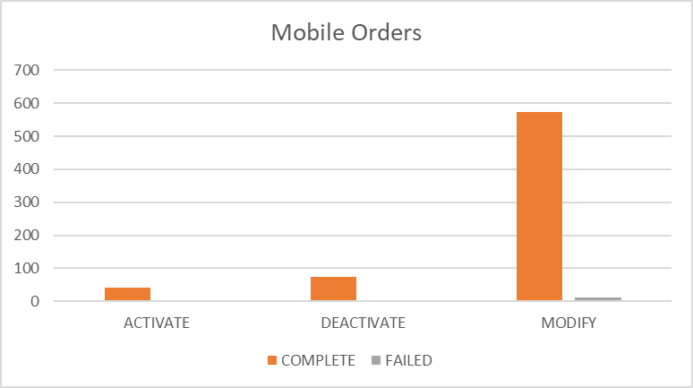

Percentages for all mobile activations, changes and deactivations Antigua

 | TOTAL | COMPLETE | FAILED | % Total | % COMPLETE | % FAILED
ACTIVATE | 79 | 66 | 13 | 8% | 84% | 16%
DEACTIVATE | 270 | 270 | 0 | 26% | 100% | 0%
MODIFY | 679 | 645 | 34 | 66% | 95% | 5%
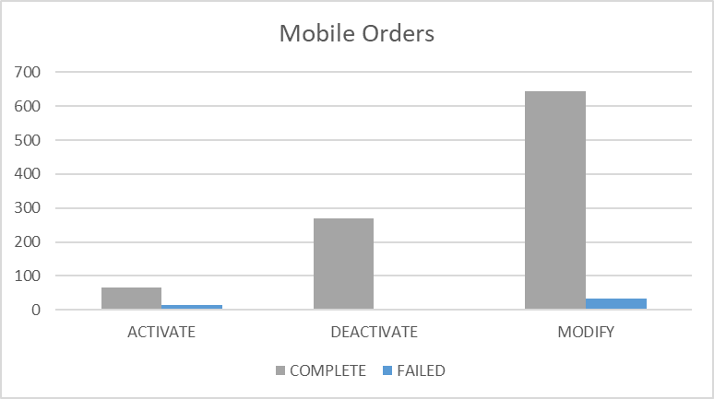

Percentages for all mobile activations, changes and deactivations Barbados

 | TOTAL | COMPLETE | FAILED | % Total | % COMPLETE | % FAILED
ACTIVATE | 32 | 21 | 11 | 1% | 66% | 34%
DEACTIVATE | 864 | 864 | 0 | 37% | 100% | 0%
MODIFY | 1415 | 1354 | 61 | 61% | 96% | 4%

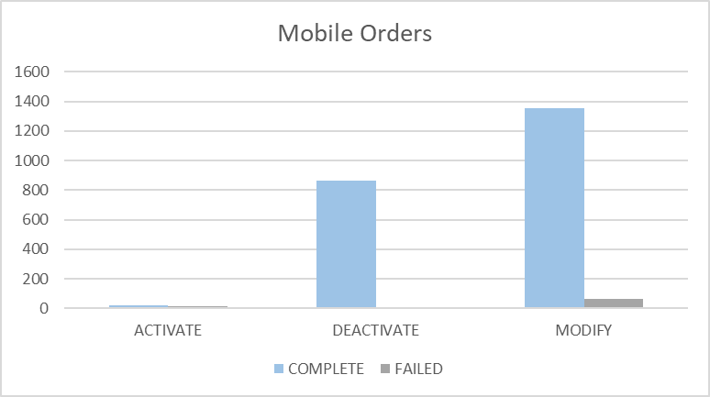

Percentages for all mobile activations, changes and deactivations British Virgin Islands

 | TOTAL | COMPLETE | FAILED | % Total | % COMPLETE | % FAILED
ACTIVATE | 133 | 132 | 1 | 9% | 99% | 1%
DEACTIVATE | 415 | 415 | 0 | 29% | 100% | 0%
MODIFY | 904 | 902 | 2 | 62% | 100% | 0%
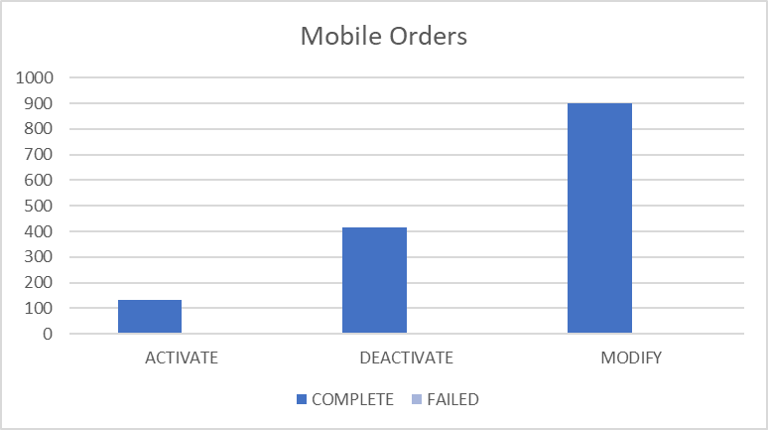

Percentages for all mobile activations, changes and deactivations Cayman

 | TOTAL | COMPLETE | FAILED | % Total | % COMPLETE | % FAILED
ACTIVATE | 81 | 81 | 0 | 4% | 100% | 0%
DEACTIVATE | 320 | 320 | 0 | 16% | 100% | 0%
MODIFY | 1608 | 1571 | 37 | 80% | 98% | 2%

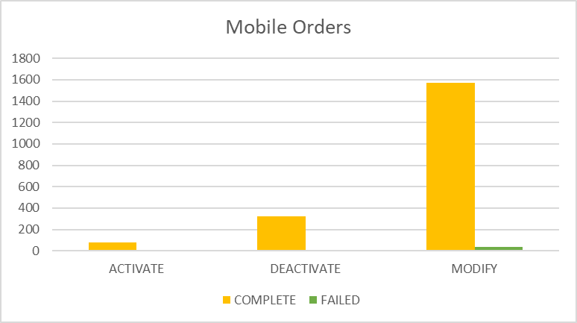

Percentages for all mobile activations, changes and deactivations Dominica

 | TOTAL | COMPLETE | FAILED | % Total | % COMPLETE | % FAILED
ACTIVATE | 81 | 80 | 1 | 6% | 99% | 1%
DEACTIVATE | 329 | 329 | 0 | 26% | 100% | 0%
MODIFY | 837 | 832 | 5 | 67% | 99% | 1%
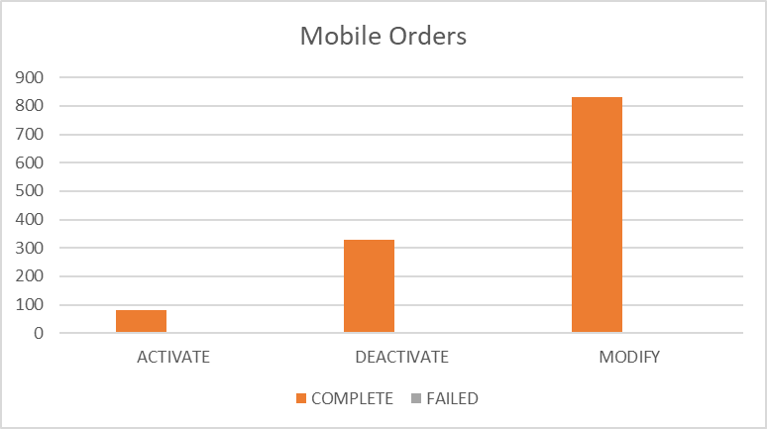

Percentages for all mobile activations, changes and deactivations Grenada

 | TOTAL | COMPLETE | FAILED | % Total | % COMPLETE | % FAILED
ACTIVATE | 83 | 83 | 0 | 7% | 100% | 0%
DEACTIVATE | 384 | 383 | 1 | 32% | 100% | 0%
MODIFY | 723 | 719 | 4 | 61% | 99% | 1%
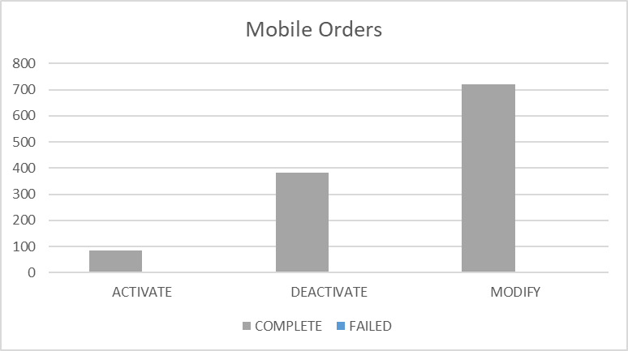

Percentages for all mobile activations, changes and deactivations Jamaica

 | TOTAL | COMPLETE | FAILED | % Total | % COMPLETE | % FAILED
ACTIVATE | 2453 | 2438 | 15 | 10% | 99% | 1%
DEACTIVATE | 6405 | 6405 | 0 | 27% | 100% | 0%
MODIFY | 14899 | 14857 | 42 | 63% | 100% | 0%

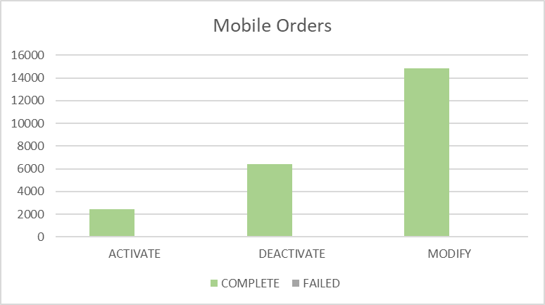

Percentages for all mobile activations, changes and deactivations Monserrat

 | TOTAL | COMPLETE | FAILED | % Total | % COMPLETE | % FAILED
ACTIVATE | 15 | 15 | 0 | 20% | 100% | 0%
DEACTIVATE | 10 | 10 | 0 | 14% | 100% | 0%
MODIFY | 49 | 49 | 0 | 66% | 100% | 0%

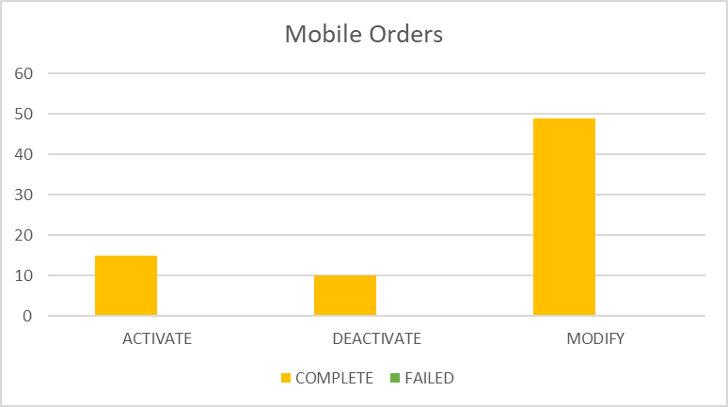

Percentages for all mobile activations, changes and deactivations Saint Vincent

 | TOTAL | COMPLETE | FAILED | % Total | % COMPLETE | % FAILED
ACTIVATE | 44 | 44 | 0 | 4% | 100% | 0%
DEACTIVATE | 466 | 466 | 0 | 37% | 100% | 0%
MODIFY | 737 | 734 | 3 | 59% | 100% | 0%
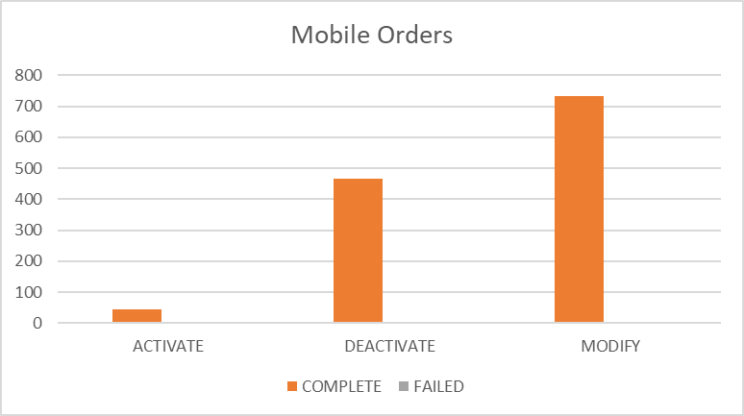

Percentages for all mobile activations, changes and deactivations Turks and Caicos

 | TOTAL | COMPLETE | FAILED | % Total | % COMPLETE | % FAILED
ACTIVATE | 165 | 142 | 23 | 16% | 86% | 14%
DEACTIVATE | 210 | 210 | 0 | 20% | 100% | 0%
MODIFY | 676 | 561 | 115 | 64% | 83% | 17%

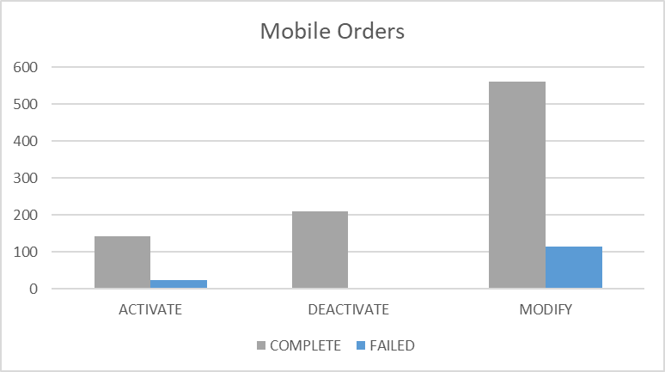

Percentages for all mobile activations, changes and deactivations Santa Lucia

 | TOTAL | COMPLETE | FAILED | % Total | % COMPLETE | % FAILED
ACTIVATE | 503 | 501 | 2 | 20% | 100% | 0%
DEACTIVATE | 405 | 405 | 0 | 16% | 100% | 0%
MODIFY | 1564 | 1547 | 17 | 63% | 99% | 1%

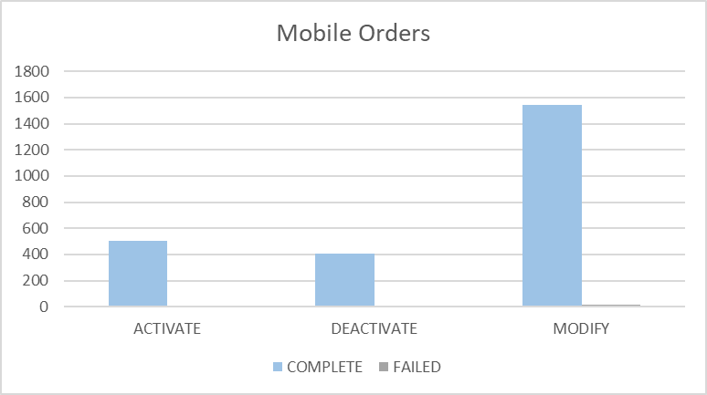

Percentages for all mobile activations, changes and deactivations Saint Kitts and Nevis

 | TOTAL | COMPLETE | FAILED | % Total | % COMPLETE | % FAILED
ACTIVATE | 176 | 176 | 0 | 15% | 100% | 0%
DEACTIVATE | 185 | 185 | 0 | 16% | 100% | 0%
MODIFY | 776 | 774 | 2 | 68% | 100% | 0%
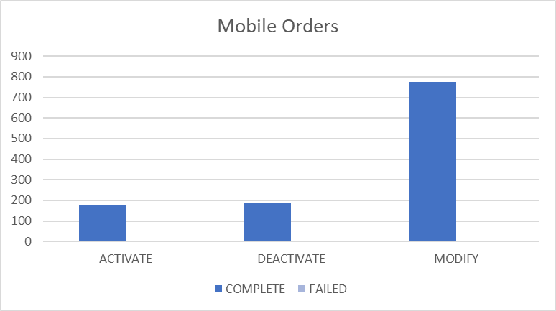

Top 5 failure issues Anguilla

AMOUNT | USER EXIT TYPES
5 | SAPC_EXCEPTION:The NE was denid due to general exception
4 | EMA_MISS_REQ_PARAM:Mandatory parameter is missing from work order
3 | EMA_RESP_35101:Missing or invalid parameter.

Top 5 failure issues Antigua

AMOUNT | USER EXIT TYPES
20 | EMA_RESP_35101:Missing or invalid parameter.
9 | EMA_MISS_REQ_PARAM:Mandatory parameter is missing from work order
2 | EMA_RESP_1:The Specified IMSI is already defined
2 | EMA_RESP_14:The Specified MSISDN is not defined
1 | EMA_RESP_35105:The subscriber already exists.

Top 5 failure issues Barbados

AMOUNT | USER EXIT TYPES
17 | EMA_RESP_14:The Specified MSISDN is not defined
15 | EMA_RESP_27:Operation not allowed due to interaction
7 | NGVM_ETTY_DSNT_EXST:The specified Mailbox ID does not exist on the Comverse Voicemail platform.
6 | EMA_RESP_35101:Missing or invalid parameter.
4 | EMA_RESP_2:The Specified MSISDN is already defined with a different IMSI
3 | EMA_RESP_13:The Specified IMSI is not defined
3 | FAIL:No such object
3 | SAPC_EXCEPTION:The NE was denid due to general exception
1 | EMA_RESP_35105:The subscriber already exists.
1 | EMA_RESP_41:BSG not subscribed
1 | EMA_NO_UDET_MATCH:No User Defined Exit Type Found

Top 5 failure issues British Virgin Islands

AMOUNT | USER EXIT TYPES
1 | FAIL:No such object
1 | EMA_RESP_35101:Missing or invalid parameter.

Top 5 failure issues Cayman

AMOUNT | USER EXIT TYPES
28 | EMA_RESP_35106:The subscriber does not exist.
8 | SAPC_PROVCARTEXP:The NE was denid due to provisioning cartridge exception
1 | EMA_RESP_6:Subscriber authentication data not found

Top 5 failure issues Dominica

AMOUNT | USER EXIT TYPES
2 | EMA_RESP_1:The Specified IMSI is already defined
2 | EMA_MISS_REQ_PARAM:Mandatory parameter is missing from work order
1 | EMA_RESP_35105:The subscriber already exists.

Top 5 failure issues Grenada

AMOUNT | USER EXIT TYPES
3 | EMA_RESP_1:The Specified IMSI is already defined
1 | EMA_RESP_1001:External system communication link failure.

Top 5 failure issues Jamaica

AMOUNT | USER EXIT TYPES
9 | EMA_RESP_35101:Missing or invalid parameter.
9 | NGVM_ETTY_DSNT_EXST:The specified Mailbox ID does not exist on the Comverse Voicemail platform.
7 | EMA_RESP_2:The Specified MSISDN is already defined with a different IMSI
6 | SAPC_PROVCARTEXP:The NE was denid due to provisioning cartridge exception
4 | SAPC_EXCEPTION:The NE was denid due to general exception
3 | EMA_RESP_1:The Specified IMSI is already defined
1 | EMA_RESP_6:Subscriber authentication data not found
1 | EMA_RESP_35106:The subscriber does not exist.
1 | FAIL:No such object
1 | EMA_MISS_REQ_PARAM:Mandatory parameter is missing from work order

Top 5 failure issues Monserrat

NO ROWS SELECTED

Top 5 failure issues Saint Vincent

AMOUNT | USER EXIT TYPES
3 | EMA_RESP_1:The Specified IMSI is already defined

Top 5 failure issues Turks and Caicos

AMOUNT | USER EXIT TYPES
53 | EMA_RESP_35106:The subscriber does not exist.
26 | EMA_RESP_35101:Missing or invalid parameter.
24 | EMA_RESP_1:The Specified IMSI is already defined
6 | EMA_RESP_2:The Specified MSISDN is already defined with a different IMSI
4 | FAIL:No such object
1 | NGVM_ETTY_DSNT_EXST:The specified Mailbox ID does not exist on the Comverse Voicemail platform.
1 | EMA_RESP_35105:The subscriber already exists.

Top 5 failure issues Santa Lucia

AMOUNT | USER EXIT TYPES
7 | EMA_RESP_1:The Specified IMSI is already defined
4 | SAPC_PROVCARTEXP:The NE was denid due to provisioning cartridge exception
2 | FAIL:Invalid syntax
2 | EMA_MISS_REQ_PARAM:Mandatory parameter is missing from work order
1 | EMA_RESP_35105:The subscriber already exists.
1 | FAIL:No such object

Top 5 failure issues Saint Kitts and Nevis

AMOUNT | USER EXIT TYPES
1 | SAPC_EXCEPTION:The NE was denid due to general exception
1 | SAPC_PROVCARTEXP:The NE was denid due to provisioning cartridge exception

Failure numbers Anguilla

SRQ_ID | WO_ID | WO_STATUS | MSISDN
1054444 | CIS:BAR:1136989:172.21.64.11:25010:1534869686732 | FAILED | 12647727621
1055355 | CIS:BAR:1137023:172.21.64.11:25010:1534874275808 | FAILED | 12647295334
1056401 | CIS:BAR:1137096:172.21.64.11:25010:1534882234399 | FAILED | 12642355984
1059623 | CIS:BAR:1137136:172.21.64.11:25010:1534940561572 | FAILED | 12644765529
1059640 | CIS:BAR:1137141:172.21.64.11:25010:1534942010918 | FAILED | 12644766864
1061431 | CIS:BAR:1137210:172.21.64.11:25010:1534954120549 | FAILED | 12642358737
1061449 | CIS:BAR:1137212:172.21.64.11:25010:1534954204325 | FAILED | 12642358737
1061902 | CIS:BAR:1137237:172.21.64.11:25010:1534956610609 | FAILED | 12647294372
1080402 | CIS:BAR:1140594:172.21.64.11:25010:1535117527748 | FAILED | 12647298913
1081244 | CIS:BAR:1140712:172.21.64.11:25010:1535124592440 | FAILED | 12644766463
1083012 | CIS:BAR:1140878:172.21.64.11:25010:1535136407359 | FAILED | 12642355294
1083034 | CIS:BAR:1140889:172.21.64.11:25010:1535136594837 | FAILED | 12642358587

Failure numbers Antigua

SRQ_ID | WO_ID | WO_STATUS | MSISDN
1043675 | CIS:BAR:3001719:172.21.64.6:25009:1534766997658 | FAILED | 12687720428
1044628 | CIS:BAR:3001810:172.21.64.6:25009:1534777996871 | FAILED | 12687784503
1045003 | CIS:BAR:3001817:172.21.64.6:25009:1534780868442 | FAILED | 12687235699
1045266 | CIS:BAR:3001848:172.21.64.6:25009:1534782543950 | FAILED | 12687892536
1045277 | CIS:BAR:3001860:172.21.64.6:25009:1534782627263 | FAILED | 12687892536
1045286 | CIS:BAR:3001865:172.21.64.6:25009:1534782741176 | FAILED | 12687892536
1045292 | CIS:BAR:3001868:172.21.64.6:25009:1534782787458 | FAILED | 12687892536
1045370 | CIS:BAR:3001893:172.21.64.6:25009:1534783328868 | FAILED | 12687892536
1052976 | CIS:BAR:3002227:172.21.64.6:25009:1534856795012 | FAILED | 12687282046
1052981 | CIS:BAR:3002230:172.21.64.6:25009:1534856988899 | FAILED | 12687282046
1053051 | CIS:BAR:3002237:172.21.64.6:25009:1534857761093 | FAILED | 12687286238
1053622 | CIS:BAR:3002317:172.21.64.6:25009:1534864174104 | FAILED | 12687760420
1055931 | CIS:BAR:3002483:172.21.64.6:25009:1534878316245 | FAILED | 12687761786
1055944 | CIS:BAR:3002489:172.21.64.6:25009:1534878403036 | FAILED | 12687761786
1055973 | CIS:BAR:3002495:172.21.64.6:25009:1534878537007 | FAILED | 12687761786
1061646 | CIS:BAR:3002883:172.21.64.6:25009:1534955324720 | FAILED | 12687640096
1062256 | CIS:BAR:3002907:172.21.64.6:25009:1534958611600 | FAILED | 12687725766
1062605 | CIS:BAR:3002916:172.21.64.6:25009:1534961061074 | FAILED | 12687840809
1062628 | CIS:BAR:3002924:172.21.64.6:25009:1534961284393 | FAILED | 12687865150
1071536 | CIS:BAR:3003268:172.21.64.6:25009:1535032478524 | FAILED | 12687724393
1071725 | CIS:BAR:3003306:172.21.64.6:25009:1535034993080 | FAILED | 12687234072
1073153 | CIS:BAR:3003405:172.21.64.6:25009:1535044428429 | FAILED | 12687892949
1074142 | CIS:BAR:3003421:172.21.64.6:25009:1535050202882 | FAILED | 12687865432
1074155 | CIS:BAR:3003423:172.21.64.6:25009:1535050388268 | FAILED | 12687865432
1074288 | CIS:BAR:3003429:172.21.64.6:25009:1535050928558 | FAILED | 12687865432
1074875 | CIS:BAR:3003462:172.21.64.6:25009:1535054537223 | FAILED | 12687827411
1080898 | CIS:BAR:3003738:172.21.64.6:25009:1535121737917 | FAILED | 12684644979
1081411 | CIS:BAR:3003768:172.21.64.6:25009:1535125748664 | FAILED | 12687232210
1081502 | CIS:BAR:3003783:172.21.64.6:25009:1535126355697 | FAILED | 12687840319
1081745 | CIS:BAR:3003807:172.21.64.6:25009:1535128171190 | FAILED | 12687700943
1090147 | CIS:BAR:3004349:172.21.64.6:25009:1535223424461 | FAILED | 12684649453
1090285 | CIS:BAR:3004358:172.21.64.6:25009:1535225002889 | FAILED | 12684649453
1090293 | CIS:BAR:3004361:172.21.64.6:25009:1535225084179 | FAILED | 12684649453
1090303 | CIS:BAR:3004364:172.21.64.6:25009:1535225147849 | FAILED | 12684649453

Failure numbers Barbados

SRQ_ID | WO_ID | WO_STATUS | MSISDN
1043764 | CIS:BAR:23809830:172.21.64.13:25001:1534768816991 | FAILED | 12462315932
1044200 | CIS:BAR:23809857:172.21.64.13:25001:1534774607530 | FAILED | 12462360677
1046092 | OCA-6410 | FAILED | 12462519634
1046188 | OCA-6414 | FAILED | 12462519634
1047403 | OCA-6441 | FAILED | 12462555635
1047821 | OCA-6453 | FAILED | 12462530368
1047970 | OCA-6455a | FAILED | 12462530368
1053816 | OCA-6481 | FAILED | 12462555805
1053939 | OCA-6489 | FAILED | 12462317523
1054162 | OCA-6494 | FAILED | 12462439941
1055596 | OCA-6510 | FAILED | 12462302297
1055625 | CIS:BAR:23810064:172.21.64.13:25001:1534876753057 | FAILED | 12462303606
1055629 | CIS:BAR:23810065:172.21.64.13:25001:1534876797829 | FAILED | 12462334437
1055633 | CIS:BAR:23810066:172.21.64.13:25001:1534876827990 | FAILED | 12462334439
1061011 | OCA-6529 | FAILED | 12462434856
1062435 | OCA-6546 | FAILED | 1246279450
1063006 | OCA-6560 | FAILED | 12462439903
1063529 | CIS:BAR:23811472:172.21.64.13:25001:1534967655872 | FAILED | 12462457315
1064467 | CIS:BAR:23811511:172.21.64.13:25001:1534974872333 | FAILED | 12462421641
1064505 | CIS:BAR:23811522:172.21.64.13:25001:1534975281123 | FAILED | 12462472037
1071191 | OCA-6579 | FAILED | 12462340786
1071409 | OCA-6580 | FAILED | 12462340786
1071432 | OCA-6586 | FAILED | 12462340786
1072567 | CIS:BAR:23812421:172.21.64.13:25001:1535040889303 | FAILED | 12462387196
1072648 | CIS:BAR:23812433:172.21.64.13:25001:1535041344200 | FAILED | 12462318375
1072652 | CIS:BAR:23812439:172.21.64.13:25001:1535041403342 | FAILED | 12462318375
1073728 | OCA-6606 | FAILED | 12462305066
1073944 | OCA-6609 | FAILED | 12462305066
1074014 | OCA-6614 | FAILED | 12462305066
1074039 | OCA-6617 | FAILED | 12462305066
1074130 | CIS:BAR:23812519:172.21.64.13:25001:1535050093166 | FAILED | 12462322467
1074145 | CIS:BAR:23812526:172.21.64.13:25001:1535050215573 | FAILED | 12462322467
1074147 | CIS:BAR:23812533:172.21.64.13:25001:1535050247303 | FAILED | 12462322467
1074148 | OCA-6623 | FAILED | 12462305066
1074152 | OCA-6625 | FAILED | 12462305066
1074157 | OCA-6629 | FAILED | 12462305066
1074271 | OCA-6636 | FAILED | 12462305066
1074315 | OCA-6638 | FAILED | 12462305066
1074421 | OCA-6645 | FAILED | 12462305066
1074432 | OCA-6648 | FAILED | 12462305066
1074700 | CIS:BAR:23812592:172.21.64.13:25001:1535053414817 | FAILED | 12462503837
1074813 | OCA-6671 | FAILED | 12462305066
1074908 | OCA-6679 | FAILED | 12462305066
1074923 | OCA-6682 | FAILED | 12462305066
1074934 | OCA-6685 | FAILED | 12462305066
1074951 | OCA-6687N | FAILED | 12462305066
1079977 | OCA-6714 | FAILED | 12462531285
1080843 | CIS:BAR:23813349:172.21.64.13:25001:1535121377097 | FAILED | 12462457315
1080846 | CIS:BAR:23813350:172.21.64.13:25001:1535121409818 | FAILED | 12462457315
1080854 | CIS:BAR:23813351:172.21.64.13:25001:1535121502121 | FAILED | 12462457315
1080900 | CIS:BAR:23813360:172.21.64.13:25001:1535121744073 | FAILED | 12462457315
1080911 | CIS:BAR:23813362:172.21.64.13:25001:1535121887667 | FAILED | 12462457315
1080920 | CIS:BAR:23813363:172.21.64.13:25001:1535121914697 | FAILED | 12462457315
1080927 | CIS:BAR:23813368:172.21.64.13:25001:1535121984847 | FAILED | 12462457315
1080956 | CIS:BAR:23813371:172.21.64.13:25001:1535122102198 | FAILED | 12462457315
1080976 | CIS:BAR:23813377:172.21.64.13:25001:1535122261631 | FAILED | 12462457315
1081008 | CIS:BAR:23813378:172.21.64.13:25001:1535122550125 | FAILED | 12462457315
1081021 | CIS:BAR:23813380:172.21.64.13:25001:1535122637543 | FAILED | 12462457315
1091552 | CIS:BAR:23814339:172.21.64.13:25001:1535240718316 | FAILED | 12462308144
1093306 | CIS:BAR:23815122:172.21.64.13:25001:1535285080369 | FAILED | 12462362279
1093307 | CIS:BAR:23815123:172.21.64.13:25001:1535285123031 | FAILED | 12462362279

Failure numbers British Virgin Islands

SRQ_ID | WO_ID | WO_STATUS | MSISDN
1083574 | CIS:BAR:2890151:172.21.64.3:25002:1535140679807 | FAILED | 12845477082
1083900 | CIS:BAR:2890176:172.21.64.3:25002:1535143511702 | FAILED | 12845401010

Failure numbers Cayman

SRQ_ID | WO_ID | WO_STATUS | MSISDN
1043980 | CIS:CAY:6085618:172.21.64.16:25003:1534772745611 | FAILED | 13459285933
1046174 | CIS:CAY:6086005:172.21.64.16:25003:1534790449165 | FAILED | 13459388024
1046181 | CIS:CAY:6086009:172.21.64.16:25003:1534790480674 | FAILED | 13459388024
1046184 | CIS:CAY:6086013:172.21.64.16:25003:1534790506655 | FAILED | 13459388024
1046272 | CIS:CAY:6086017:172.21.64.16:25003:1534791107759 | FAILED | 13459388024
1046942 | CIS:CAY:6086085:172.21.64.16:25003:1534797346800 | FAILED | 13459260549
1053991 | CIS:CAY:6086662:172.21.64.16:25003:1534867208068 | FAILED | 13459254386
1054196 | CIS:CAY:6086992:172.21.64.16:25003:1534867995777 | FAILED | 13459247238
1054377 | CIS:CAY:6087120:172.21.64.16:25003:1534869159203 | FAILED | 13459162225
1054898 | CIS:CAY:6087487:172.21.64.16:25003:1534871420212 | FAILED | 13459268967
1054932 | CIS:CAY:6087526:172.21.64.16:25003:1534871644546 | FAILED | 13459264263
1054937 | CIS:CAY:6087529:172.21.64.16:25003:1534871668865 | FAILED | 13459262671
1054939 | CIS:CAY:6087531:172.21.64.16:25003:1534871692185 | FAILED | 13459264716
1055049 | CIS:CAY:6087656:172.21.64.16:25003:1534872342517 | FAILED | 13459363030
1055063 | CIS:CAY:6087675:172.21.64.16:25003:1534872455193 | FAILED | 13459267626
1055147 | CIS:CAY:6087838:172.21.64.16:25003:1534872874171 | FAILED | 13459162225
1055223 | CIS:CAY:6087967:172.21.64.16:25003:1534873283152 | FAILED | 13459160035
1060616 | CIS:CAY:6089081:172.21.64.16:25003:1534948910154 | FAILED | 13459268967
1061477 | CIS:CAY:6089376:172.21.64.16:25003:1534954374212 | FAILED | 13459396876
1061487 | CIS:CAY:6089400:172.21.64.16:25003:1534954439833 | FAILED | 13459160707
1061605 | CIS:CAY:6089586:172.21.64.16:25003:1534955113443 | FAILED | 13459167119
1061807 | CIS:CAY:6089917:172.21.64.16:25003:1534956063621 | FAILED | 13459167798
1062179 | CIS:CAY:6090185:172.21.64.16:25003:1534957728543 | FAILED | 13459160707
1062504 | CIS:CAY:6090524:172.21.64.16:25003:1534960251101 | FAILED | 13459167798
1062862 | CIS:CAY:6090701:172.21.64.16:25003:1534963487963 | FAILED | 13459167119
1063927 | CIS:CAY:6090857:172.21.64.16:25003:1534969249521 | FAILED | 13459363030
1063972 | CIS:CAY:6090885:172.21.64.16:25003:1534969740061 | FAILED | 13459267626
1064216 | CIS:CAY:6090955:172.21.64.16:25003:1534972188134 | FAILED | 13459396876
1072191 | CIS:JAM:6091414:172.21.64.16:25003:1535038230728 | FAILED | 13459168787
1072199 | CIS:JAM:6091417:172.21.64.16:25003:1535038351750 | FAILED | 13459168787
1072216 | CIS:JAM:6091424:172.21.64.16:25003:1535038405563 | FAILED | 13459168787
1072362 | CIS:CAY:6091492:172.21.64.16:25003:1535039614964 | FAILED | 13459254386
1091795 | CIS:JAM:6093805:172.21.64.16:25003:1535257736020 | FAILED | 13455483867
1091796 | CIS:JAM:6093807:172.21.64.16:25003:1535257817739 | FAILED | 13455483867
1091808 | CIS:JAM:6093808:172.21.64.16:25003:1535257881943 | FAILED | 13455483867
1091867 | CIS:JAM:6093809:172.21.64.16:25003:1535258059045 | FAILED | 13455483867
1093375 | CIS:JAM:6094014:172.21.64.16:25003:1535292150428 | FAILED | 13459169147

Failure numbers Dominica

SRQ_ID | WO_ID | WO_STATUS | MSISDN
1044901 | CIS:BAR:4282551:172.21.64.4:25008:1534780235583 | FAILED | 17672452502
1044910 | CIS:BAR:4282553:172.21.64.4:25008:1534780320930 | FAILED | 17672452502
1044926 | CIS:BAR:4282554:172.21.64.4:25008:1534780385900 | FAILED | 17672452502
1062255 | CIS:BAR:4284504:172.21.64.4:25008:1534958588609 | FAILED | 17672251556
1080270 | CIS:BAR:4285716:172.21.64.4:25008:1535116008523 | FAILED | 17672958540

Failure Numbers Grenada

SRQ_ID | WO_ID | WO_STATUS | MSISDN
1051586 | CIS:BAR:5485757:172.21.64.14:25004:1534843321282 | FAILED | 14734565339
1056613 | CIS:BAR:5492258:172.21.64.14:25004:1534884007758 | FAILED | 14734578010
1062204 | CIS:BAR:5493241:172.21.64.14:25004:1534957991246 | FAILED | 14734564123
1069578 | CIS:BAR:5494148:172.21.64.14:25004:1535005041566 | FAILED | 14734042769

Failure numbers Jamaica

SRQ_ID | WO_ID | WO_STATUS | MSISDN
1044206 | CIS:JAM:185850307:172.21.64.17:25007:1534774667891 | FAILED | 18768086949
1044801 | CIS:JAM:185851951:172.21.64.17:25007:1534779308795 | FAILED | 18768199827
1046337 | CIS:JAM:185856152:172.21.64.17:25007:1534791737287 | FAILED | 18768061963
1046388 | CIS:JAM:185856319:172.21.64.17:25007:1534792275010 | FAILED | 18768066554
1046437 | CIS:JAM:185856490:172.21.64.17:25007:1534792761642 | FAILED | 18768066554
1046446 | CIS:JAM:185856503:172.21.64.17:25007:1534792845416 | FAILED | 18768066554
1046452 | CIS:JAM:185856517:172.21.64.17:25007:1534792903940 | FAILED | 18768066554
1046458 | CIS:JAM:185856524:172.21.64.17:25007:1534792973174 | FAILED | 18768066554
1046492 | CIS:JAM:185856618:172.21.64.17:25007:1534793234121 | FAILED | 18768913009
1046668 | CIS:JAM:185857132:172.21.64.17:25007:1534794798948 | FAILED | 18763194990
1046679 | CIS:JAM:185857161:172.21.64.17:25007:1534794875094 | FAILED | 18763194990
1047076 | CIS:JAM:185858368:172.21.64.17:25007:1534798880413 | FAILED | 18768066554
1047088 | CIS:JAM:185858399:172.21.64.17:25007:1534798964660 | FAILED | 18768066554
1052984 | CIS:JAM:185897952:172.21.64.17:25007:1534857074060 | FAILED | 18763194990
1054083 | CIS:JAM:185900397:172.21.64.17:25007:1534867374630 | FAILED | 18763100596
1054183 | CIS:JAM:185900533:172.21.64.17:25007:1534867946707 | FAILED | 18763100596
1054191 | CIS:JAM:185900562:172.21.64.17:25007:1534867983137 | FAILED | 18763100596
1054986 | CIS:JAM:185901921:172.21.64.17:25007:1534871845842 | FAILED | 18763194990
1055039 | CIS:JAM:185902075:172.21.64.17:25007:1534872273416 | FAILED | 18763194990
1059596 | CIS:JAM:185917147:172.21.64.17:25007:1534938728278 | FAILED | 18763100596
1059597 | CIS:JAM:185917152:172.21.64.17:25007:1534938791203 | FAILED | 18763100596
1061317 | CIS:JAM:185922376:172.21.64.17:25007:1534953227716 | FAILED | 18763794170
1061329 | CIS:JAM:185922404:172.21.64.17:25007:1534953314718 | FAILED | 18763794170
1064504 | CIS:JAM:185931840:172.21.64.17:25007:1534975275746 | FAILED | 18767715238
1064514 | CIS:JAM:185931862:172.21.64.17:25007:1534975406775 | FAILED | 18767715238
1064533 | CIS:JAM:185931942:172.21.64.17:25007:1534975555142 | FAILED | 18767715238
1071951 | CIS:JAM:185962632:172.21.64.17:25007:1535036232599 | FAILED | 18763514702
1072390 | CIS:JAM:185963744:172.21.64.17:25007:1535039799472 | FAILED | 18768157666
1072651 | CIS:JAM:185964349:172.21.64.17:25007:1535041397132 | FAILED | 18768185671
1073826 | CIS:JAM:185967219:172.21.64.17:25007:1535049253718 | FAILED | 18769196145
1082003 | CIS:JAM:186121640:172.21.64.17:25007:1535129396824 | FAILED | 18769903370
1084264 | CIS:JAM:186128078:172.21.64.17:25007:1535146712372 | FAILED | 18765425444
1084284 | CIS:JAM:186128154:172.21.64.17:25007:1535146882911 | FAILED | 18768279529
1084490 | CIS:JAM:186128875:172.21.64.17:25007:1535148405866 | FAILED | 18767990410
1084506 | CIS:JAM:186128948:172.21.64.17:25007:1535148448658 | FAILED | 18769973410
1090448 | CIS:JAM:186150673:172.21.64.17:25007:1535226589858 | FAILED | 18768085890
1093406 | CIS:JAM:186161153:172.21.64.17:25007:1535292995274 | FAILED | 18769952670
1093410 | CIS:JAM:186161157:172.21.64.17:25007:1535293050156 | FAILED | 18769952670
1093413 | CIS:JAM:186161163:172.21.64.17:25007:1535293087120 | FAILED | 18769952670
1093483 | CIS:JAM:186161405:172.21.64.17:25007:1535298096310 | FAILED | 18767934858
1093658 | CIS:JAM:186162067:172.21.64.17:25007:1535311402276 | FAILED | 18769975380
1093757 | CIS:JAM:186162410:172.21.64.17:25007:1535318195693 | FAILED | 18768388909

Failure numbers Monserrat

NO ROWS SELECTED

Failure numbers Saint Vincent

SRQ_ID | WO_ID | WO_STATUS | MSISDN
1069697 | CIS:BAR:3455955:172.21.64.8:25012:1535009589161 | FAILED | 17844951366
1069698 | CIS:BAR:3455957:172.21.64.8:25012:1535009589984 | FAILED | 17844544422
1069718 | CIS:BAR:3455997:172.21.64.8:25012:1535009910156 | FAILED | 17844921190

Failure numbers Turks and Caicos

SRQ_ID | WO_ID | WO_STATUS | MSISDN
1044310 | CIS:BAR:2486048:172.21.64.5:25007:1534775245604 | FAILED | 16492418705
1044320 | CIS:BAR:2486049:172.21.64.5:25007:1534775306260 | FAILED | 16492418705
1044401 | CIS:BAR:2486050:172.21.64.5:25007:1534775982074 | FAILED | 16492411052
1045079 | CIS:BAR:2486150:172.21.64.5:25007:1534781409639 | FAILED | 16492479964
1045202 | CIS:BAR:2486276:172.21.64.5:25007:1534782158030 | FAILED | 16492415530
1045307 | CIS:BAR:2486405:172.21.64.5:25007:1534782913441 | FAILED | 16492415530
1045332 | CIS:BAR:2486414:172.21.64.5:25007:1534783073704 | FAILED | 16494412529
1045517 | CIS:BAR:2486506:172.21.64.5:25007:1534784502036 | FAILED | 16492478889
1045598 | CIS:BAR:2486592:172.21.64.5:25007:1534785081990 | FAILED | 16492420556
1045923 | CIS:BAR:2486693:172.21.64.5:25007:1534787907881 | FAILED | 16492324835
1045930 | CIS:BAR:2486695:172.21.64.5:25007:1534788005793 | FAILED | 16492324835
1046065 | CIS:BAR:2486719:172.21.64.5:25007:1534789541730 | FAILED | 16492320898
1046361 | CIS:BAR:2486757:172.21.64.5:25007:1534792009560 | FAILED | 16492422646
1046472 | CIS:BAR:2486774:172.21.64.5:25007:1534793057551 | FAILED | 16492472046
1046507 | CIS:BAR:2486801:172.21.64.5:25007:1534793346837 | FAILED | 16492418320
1046699 | CIS:BAR:2486821:172.21.64.5:25007:1534794988450 | FAILED | 16492465651
1046736 | CIS:BAR:2486825:172.21.64.5:25007:1534795187857 | FAILED | 16492441819
1047327 | CIS:BAR:2486832:172.21.64.5:25007:1534801203423 | FAILED | 16492466237
1047335 | CIS:BAR:2486834:172.21.64.5:25007:1534801289756 | FAILED | 16492466237
1047481 | CIS:BAR:2486844:172.21.64.5:25007:1534803045685 | FAILED | 16492437217
1047646 | CIS:BAR:2486850:172.21.64.5:25007:1534804313478 | FAILED | 16492416820
1053041 | CIS:BAR:2486960:172.21.64.5:25007:1534857385467 | FAILED | 16492316069
1053117 | CIS:BAR:2486964:172.21.64.5:25007:1534858701691 | FAILED | 16492310146
1053300 | CIS:BAR:2487001:172.21.64.5:25007:1534861120286 | FAILED | 16492418034
1053302 | CIS:BAR:2487003:172.21.64.5:25007:1534861136005 | FAILED | 16492418034
1053333 | CIS:BAR:2487010:172.21.64.5:25007:1534861378669 | FAILED | 16494311239
1053544 | CIS:BAR:2487118:172.21.64.5:25007:1534863350589 | FAILED | 16492421410
1054209 | CIS:BAR:2487206:172.21.64.5:25007:1534868018892 | FAILED | 16492430179
1054351 | CIS:BAR:2487226:172.21.64.5:25007:1534868855044 | FAILED | 16492432792
1054375 | CIS:BAR:2487228:172.21.64.5:25007:1534869151607 | FAILED | 16492432792
1055011 | CIS:BAR:2487287:172.21.64.5:25007:1534872099977 | FAILED | 16492323292
1055027 | CIS:BAR:2487293:172.21.64.5:25007:1534872180909 | FAILED | 16494411990
1055033 | CIS:BAR:2487295:172.21.64.5:25007:1534872249203 | FAILED | 16494411990
1055095 | CIS:BAR:2487300:172.21.64.5:25007:1534872574132 | FAILED | 16492328249
1055181 | CIS:BAR:2487307:172.21.64.5:25007:1534873030426 | FAILED | 16494411990
1055204 | CIS:BAR:2487316:172.21.64.5:25007:1534873180937 | FAILED | 16494411990
1055213 | CIS:BAR:2487318:172.21.64.5:25007:1534873238901 | FAILED | 16492441439
1055234 | CIS:BAR:2487320:172.21.64.5:25007:1534873342656 | FAILED | 16494411990
1055465 | CIS:BAR:2487346:172.21.64.5:25007:1534875342270 | FAILED | 16492433594
1055528 | CIS:BAR:2487348:172.21.64.5:25007:1534875883822 | FAILED | 16492450573
1055676 | CIS:BAR:2487379:172.21.64.5:25007:1534877154151 | FAILED | 16492318874
1056051 | CIS:BAR:2487406:172.21.64.5:25007:1534879350772 | FAILED | 16494315655
1056176 | CIS:BAR:2487408:172.21.64.5:25007:1534879725638 | FAILED | 16492476461
1056354 | CIS:BAR:2487439:172.21.64.5:25007:1534881608831 | FAILED | 16492429063
1056363 | CIS:BAR:2487447:172.21.64.5:25007:1534881750843 | FAILED | 16492429063
1056547 | CIS:BAR:2487463:172.21.64.5:25007:1534883520699 | FAILED | 16492416537
1057288 | CIS:NOR:2487470:172.21.64.5:25007:1534890960723 | FAILED | 16492421494
1057297 | CIS:BAR:2487471:172.21.64.5:25007:1534891122426 | FAILED | 16492472511
1059837 | CIS:BAR:2487651:172.21.64.5:25007:1534943545633 | FAILED | 16492427055
1060197 | CIS:BAR:2487724:172.21.64.5:25007:1534946874610 | FAILED | 16492476726
1060967 | CIS:BAR:2487814:172.21.64.5:25007:1534950733965 | FAILED | 16492328304
1060991 | CIS:BAR:2487816:172.21.64.5:25007:1534950810216 | FAILED | 16492328304
1061748 | CIS:BAR:2487890:172.21.64.5:25007:1534955750654 | FAILED | 16492419817
1061790 | CIS:BAR:2487904:172.21.64.5:25007:1534955949580 | FAILED | 16492424242
1061859 | CIS:BAR:2487915:172.21.64.5:25007:1534956416544 | FAILED | 16492324336
1061866 | CIS:BAR:2487917:172.21.64.5:25007:1534956455286 | FAILED | 16492418917
1062209 | CIS:BAR:2487934:172.21.64.5:25007:1534958068973 | FAILED | 16492468332
1062214 | CIS:BAR:2487938:172.21.64.5:25007:1534958132253 | FAILED | 16494320090
1062250 | CIS:BAR:2487947:172.21.64.5:25007:1534958529167 | FAILED | 16492411000
1062524 | CIS:BAR:2487963:172.21.64.5:25007:1534960458484 | FAILED | 16492413167
1063218 | CIS:BAR:2488027:172.21.64.5:25007:1534965707018 | FAILED | 16492447166
1063347 | CIS:BAR:2488043:172.21.64.5:25007:1534966263160 | FAILED | 16494326330
1064308 | CIS:BAR:2488095:172.21.64.5:25007:1534973411452 | FAILED | 16492411706
1064687 | CIS:BAR:2488109:172.21.64.5:25007:1534977936530 | FAILED | 16492476114
1071363 | CIS:BAR:2488206:172.21.64.5:25007:1535029442750 | FAILED | 16492476114
1072660 | CIS:BAR:2488393:172.21.64.5:25007:1535041568157 | FAILED | 16492418497
1072665 | CIS:BAR:2488397:172.21.64.5:25007:1535041623949 | FAILED | 16494413065
1072799 | CIS:BAR:2488408:172.21.64.5:25007:1535042031361 | FAILED | 16492417236
1072800 | CIS:BAR:2488410:172.21.64.5:25007:1535042048645 | FAILED | 16492417236
1074067 | CIS:BAR:2488513:172.21.64.5:25007:1535049756113 | FAILED | 16492441468
1074684 | CIS:BAR:2488546:172.21.64.5:25007:1535053301039 | FAILED | 16492315560
1074731 | CIS:BAR:2488550:172.21.64.5:25007:1535053695900 | FAILED | 16492471421
1074750 | CIS:BAR:2488556:172.21.64.5:25007:1535053863149 | FAILED | 16494325454
1074752 | CIS:BAR:2488557:172.21.64.5:25007:1535053896953 | FAILED | 16494325454
1074775 | CIS:BAR:2488563:172.21.64.5:25007:1535054040144 | FAILED | 16492461848
1080250 | CIS:BAR:2488743:172.21.64.5:25007:1535115388931 | FAILED | 16492321199
1080724 | CIS:BAR:2488788:172.21.64.5:25007:1535120757837 | FAILED | 16492449077
1081159 | CIS:BAR:2488826:172.21.64.5:25007:1535123790699 | FAILED | 16492464994
1081446 | CIS:BAR:2488866:172.21.64.5:25007:1535125975750 | FAILED | 16492421342
1081450 | CIS:BAR:2488868:172.21.64.5:25007:1535125992772 | FAILED | 16492412560
1081569 | CIS:BAR:2488875:172.21.64.5:25007:1535126898830 | FAILED | 16492430538
1081723 | CIS:BAR:2488885:172.21.64.5:25007:1535127943481 | FAILED | 16492434393
1081853 | CIS:BAR:2488894:172.21.64.5:25007:1535128431616 | FAILED | 16492434393
1081875 | CIS:BAR:2488896:172.21.64.5:25007:1535128502406 | FAILED | 16492434393
1081898 | CIS:BAR:2488898:172.21.64.5:25007:1535128690038 | FAILED | 16492434393
1082115 | CIS:BAR:2488914:172.21.64.5:25007:1535130376604 | FAILED | 16492411940
1082138 | CIS:BAR:2488916:172.21.64.5:25007:1535130644607 | FAILED | 16492411940
1082463 | CIS:BAR:2488927:172.21.64.5:25007:1535132271132 | FAILED | 16492420183
1082501 | CIS:BAR:2488932:172.21.64.5:25007:1535132573173 | FAILED | 16492474939
1082751 | CIS:BAR:2488961:172.21.64.5:25007:1535134557111 | FAILED | 16494326330
1082761 | CIS:BAR:2488966:172.21.64.5:25007:1535134651857 | FAILED | 16494326330
1082776 | CIS:BAR:2488967:172.21.64.5:25007:1535134791894 | FAILED | 16494326330
1082825 | CIS:BAR:2488974:172.21.64.5:25007:1535135162448 | FAILED | 16494326330
1082836 | CIS:BAR:2488975:172.21.64.5:25007:1535135212279 | FAILED | 16494326330
1082852 | CIS:BAR:2488976:172.21.64.5:25007:1535135330006 | FAILED | 16494326330
1083064 | CIS:BAR:2488985:172.21.64.5:25007:1535136825567 | FAILED | 16492428051
1088551 | CIS:BAR:2489168:172.21.64.5:25007:1535206823126 | FAILED | 16492315555
1089185 | CIS:BAR:2489203:172.21.64.5:25007:1535213786518 | FAILED | 16492450806
1089195 | CIS:BAR:2489205:172.21.64.5:25007:1535213951218 | FAILED | 16492450806
1089208 | CIS:BAR:2489211:172.21.64.5:25007:1535214082084 | FAILED | 16492450806
1089210 | CIS:BAR:2489216:172.21.64.5:25007:1535214110590 | FAILED | 16492450806
1089226 | CIS:BAR:2489218:172.21.64.5:25007:1535214261666 | FAILED | 16492450806
1089234 | CIS:BAR:2489220:172.21.64.5:25007:1535214329111 | FAILED | 16492450806
1089722 | CIS:BAR:2489245:172.21.64.5:25007:1535218952694 | FAILED | 16492413167
1089900 | CIS:BAR:2489252:172.21.64.5:25007:1535220597979 | FAILED | 16492463155
1090252 | CIS:BAR:2489267:172.21.64.5:25007:1535224601382 | FAILED | 16492411507
1090254 | CIS:BAR:2489269:172.21.64.5:25007:1535224660262 | FAILED | 16492411507
1090265 | CIS:BAR:2489274:172.21.64.5:25007:1535224815621 | FAILED | 16492411507
1090272 | CIS:BAR:2489278:172.21.64.5:25007:1535224934323 | FAILED | 16492411507
1090284 | CIS:BAR:2489280:172.21.64.5:25007:1535225003657 | FAILED | 16492434242
1090294 | CIS:BAR:2489282:172.21.64.5:25007:1535225091191 | FAILED | 16492434242
1090873 | CIS:BAR:2489294:172.21.64.5:25007:1535231317810 | FAILED | 16492321174
1090874 | CIS:BAR:2489296:172.21.64.5:25007:1535231388915 | FAILED | 16492434242
1090898 | CIS:BAR:2489301:172.21.64.5:25007:1535231678579 | FAILED | 16492434242
1090905 | CIS:BAR:2489305:172.21.64.5:25007:1535231840425 | FAILED | 16492434242

Failure numbers Santa Lucia

SRQ_ID | WO_ID | WO_STATUS | MSISDN
1069673 | CIS:BAR:8600485:172.21.64.7:25011:1535007495955 | FAILED | 17584619803
1069686 | CIS:BAR:8600511:172.21.64.7:25011:1535007511878 | FAILED | 17584859283
1069690 | CIS:BAR:8600519:172.21.64.7:25011:1535007519138 | FAILED | 17582856360
1069692 | CIS:BAR:8600523:172.21.64.7:25011:1535007521608 | FAILED | 17584853030
1069693 | CIS:BAR:8600525:172.21.64.7:25011:1535007856483 | FAILED | 17584857259
1069694 | CIS:BAR:8600527:172.21.64.7:25011:1535008073525 | FAILED | 17584887884
1071068 | CIS:BAR:8600742:172.21.64.7:25011:1535019303645 | FAILED | 17582840805
1071071 | CIS:BAR:8600744:172.21.64.7:25011:1535021092996 | FAILED | 17582840805
1075153 | CIS:BAR:8601500:172.21.64.7:25011:1535056681911 | FAILED | 17582861538
1080814 | CIS:BAR:8601986:172.21.64.7:25011:1535121172658 | FAILED | 17582852949
1081013 | CIS:BAR:8602048:172.21.64.7:25011:1535122593215 | FAILED | 17582852111
1083588 | CIS:BAR:8602466:172.21.64.7:25011:1535140831022 | FAILED | 17584897945
1083633 | CIS:BAR:8602473:172.21.64.7:25011:1535141206263 | FAILED | 17584611182
1083911 | CIS:BAR:8602530:172.21.64.7:25011:1535143611873 | FAILED | 17584847189
1083997 | CIS:BAR:8602559:172.21.64.7:25011:1535144445282 | FAILED | 17584847189
1084008 | CIS:BAR:8602566:172.21.64.7:25011:1535144539474 | FAILED | 17584847189
1084068 | CIS:BAR:8602589:172.21.64.7:25011:1535145022503 | FAILED | 17584847189

Failure numbers Saint Kitts and Nevis

SRQ_ID | WO_ID | WO_STATUS | MSISDN
1046196 | CIS:BAR:3660210:172.21.64.12:25006:1534790557485 | FAILED | 18696623170
1083444 | CIS:BAR:3665033:172.21.64.12:25006:1535139448764 | FAILED | 18696627579

